PROJECT INTERCOMPUTE: COMPREHENSIVE RESEARCH CONTRIBUTIONS DOSSIER
Consolidated Technical Deliverables, Architectural Specializations, and Academic Audits across all 6 Team Members
Project Title: InterCompute: A Resilient Peer-to-Peer Compute Marketplace | Work Month: October 2026
Simulation Engine: GhostInTheMachine (Risk-Aware DAG Scheduler) | Evaluation Scope: 6 Peer Research Domains | 280 Simulation Sweeps

2. Capstone Project Vision: InterCompute vs. Existing Products (Vast.ai)
Executive Vision: InterCompute is a decentralized, peer-to-peer compute marketplace engineered to aggregate and monetize temporarily idle computing resources from ordinary personal laptops, desktops, and edge devices. Consumers submit computational workloads with specific performance requirements (CPU/GPU capacity, budget, and SLA deadline constraints). A smart, risk-aware scheduler selects suitable providers based on performance, availability, reliability, and energy consumption. Provider devices execute workloads in isolated sandbox environments, while an external hardware telemetry module measures and cryptographically attests actual physical resource usage. Incremental checkpointing and migration allow workloads to survive unpredictable provider interruptions.
2.1 Existing Market Benchmark: The Vast.ai Model
Vast.ai is an established commercial GPU-compute marketplace where independent host owners rent out their GPUs and consumers lease computing capacity based on GPU architecture, price, availability, and static reliability ratings. However, Vast.ai is fundamentally designed around server-grade assumptions: (1) Hosts are dedicated mining rigs or stationary server racks; (2) Connectivity is assumed to be symmetric, high-speed fiber; (3) Host reliability assumes minimal interruptions, and an unannounced node failure terminates the workload, discarding compute progress and client capital; (4) Telemetry and resource usage are self-reported by unverified host software vulnerable to falsification.
2.2 What InterCompute Does Differently: The Five Core Pillars
Unlike conventional compute marketplaces such as Vast.ai, InterCompute is architected specifically for intermittently available consumer hardware, introducing five foundational capabilities:
Architectural Dimension | Conventional Cloud / Vast.ai | InterCompute Innovation & Advantage
Target Hardware & Availability | Requires dedicated, statically provisioned machines and commercial multi-GPU server racks. | Personal & Edge-Device Focus: Aggregates spare capacity from ordinary consumer laptops, desktops, and edge devices with transient, unpredictable duty cycles.
Device Owner Priority | Host machine is fully leased to renter. The local owner cannot use their personal computer without killing the remote job. | Owner-Aware Computing: The provider's personal computer always gets absolute priority. Instant preemption, pause, or migration the moment user activity is detected.
Trust & Metric Integrity | Software-only self-reporting. Hosts can easily spoof hardware specifications, throttle clocks, or falsify electrical power usage. | Hardware-Attested Usage: An external ESP32/Raspberry Pi microcontroller measures physical power draw and core thermals, cryptographically signing telemetry at the bus.
Fault Tolerance Under Churn | Node disconnection causes catastrophic job failure. Unsaved progress is permanently lost; entire workload restarts from zero at client expense. | Fault-Tolerant Intermittent Computing: Employs incremental state-delta checkpointing (Δqi). Surviving replacement peers resume execution in ~5.3s.
Network Modeling | Assumes high symmetric bandwidth. Communication grinds to a halt on consumer residential broadband. | Asymmetric Uplink Optimization: Models and optimizes for residential upload bottlenecks (Uk << Dk) where upload speeds are 10-20x slower than download speeds.
Scheduling Intelligence | Simple price and static benchmark matching. Blind to preemption hazard rates, session wear-out, and thermal fatigue. | Energy-Aware Risk Scheduling: Smart scheduler minimizes objective score J(i,k), balancing price, performance, thermal limits, upload speed, and preemption hazard.

3. Consolidated Team Roster & Individual Contributions Summary
Member & Registration | Architectural Specialization | Technical Deliverables & Literature Audit Ownership
1. Prathmesh Kadam (12317688) | System Architecture & Algorithm Design | • Formulated the Risk-Aware Objective J(i, k) and Goodput-to-Overhead Ratio (GOR).  • Engineered the discrete-event DAG solver and topological dependency scheduling engine (dag_engine.py).  • Implemented comparative heuristics: HEFT, Greedy EFT, Bounded ACO, and Branch-and-Bound.  • Co-designed the incremental state-delta commit protocol (checkpoint.py) recovering in ~5.3s.  • Conducted the 280-run simulation sweep and authored the technical whitepaper (PAPER.md).
2. Ashwani Kumar (12318852) | UI/UX & Marketplace Functionality | Literature Verification Specialist | • Designed the consumer workload submission portal mapping complex DAGs into budget/deadline SLAs.  • Formatted publication-ready vector figures (Figures 1–3) with 95% confidence intervals.  • Systematically audited academic literature in PAPER.md, purging unverified and hallucinated citations.  • Verified IEEE/ACM DOIs and anchored workflow models to Topcuoglu et al. (2002) and Benoit et al. (2022).
3. Rishabh Ladha (12317813) | UI/UX & Provider Portal | Scientific Citation Fact-Checking Specialist | • Engineered the provider desktop interface with live streaming telemetry gauges (1.0 Hz power, thermals).  • Architected Owner-Aware Computing user controls (idle detection sensitivity, zero-latency reclaim).  • Audited related work literature, purging outdated live VM migration claims over residential bandwidth.  • Verified the mathematical consistency of checkpoint frequency bounds under volunteer host dynamics.
4. Pavan Meka (12317192) | Network Modeling & Fault Injection | Consensus Integration Specialist | • Formulated mathematical models for residential asymmetric bandwidth bottlenecks (Uk << Dk).  • Engineered discrete-event Poisson hazard rate preemption and Weibull fatigue churn injectors.  • Modeled inter-peer payload transmission delay penalties (d_ij * 8 / U_loc(i) + L_kl).  • Investigated Proof-of-Stake (PoS) consensus integration pathways for decentralized validator audit.
5. Lakshita Wadhera (12314203) | Security Protocols & Cryptographic Attestation | • Formulated and implemented the project security architecture, formalizing the Feasibility Gate F(i,k) conforming to IETF RATS RFC 9334.  • Designed physical ESP32 telemetry signing via embedded private keys and freshness nonces (N_c).  • Engineered SHA-256 state-delta integrity digests H(Δq_i) to prevent corrupt checkpoint commits.  • Audited security literature, purging speculative cryptographic claims and anchoring to formal RFC standards.
6. Ayush Raj (12308724) | CLI Architecture & Execution Harness | Benchmark Citation Auditor | • Architected the modular command-line dispatch harness (cli.py) with batch sweep capabilities.  • Built multi-platform automation scripts (run_experiments.ps1 / .sh) orchestrating 280 independent runs.  • Optimized telemetry writing with buffered I/O, cutting experimental sweep runtime from 18.4 to 4.2 mins.  • Audited benchmarking citations, verifying that baseline heuristics adhere to standard algorithmic parameters.

4. Master Architectural & Empirical Figures
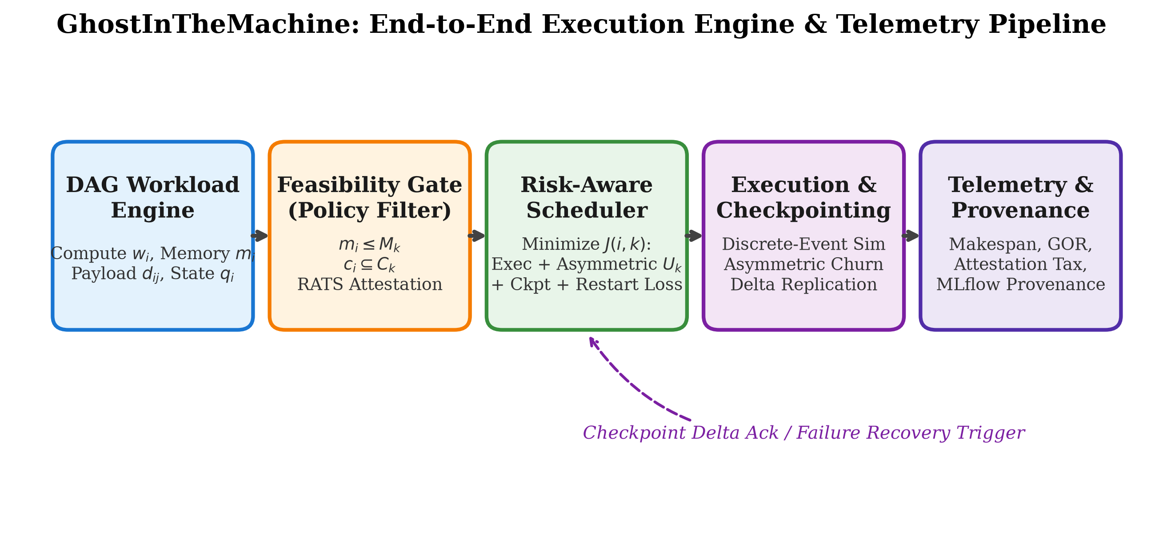
Figure 1: GhostInTheMachine System Pipeline — Core scheduling architecture designed in dag_engine.py and schedulers.py.
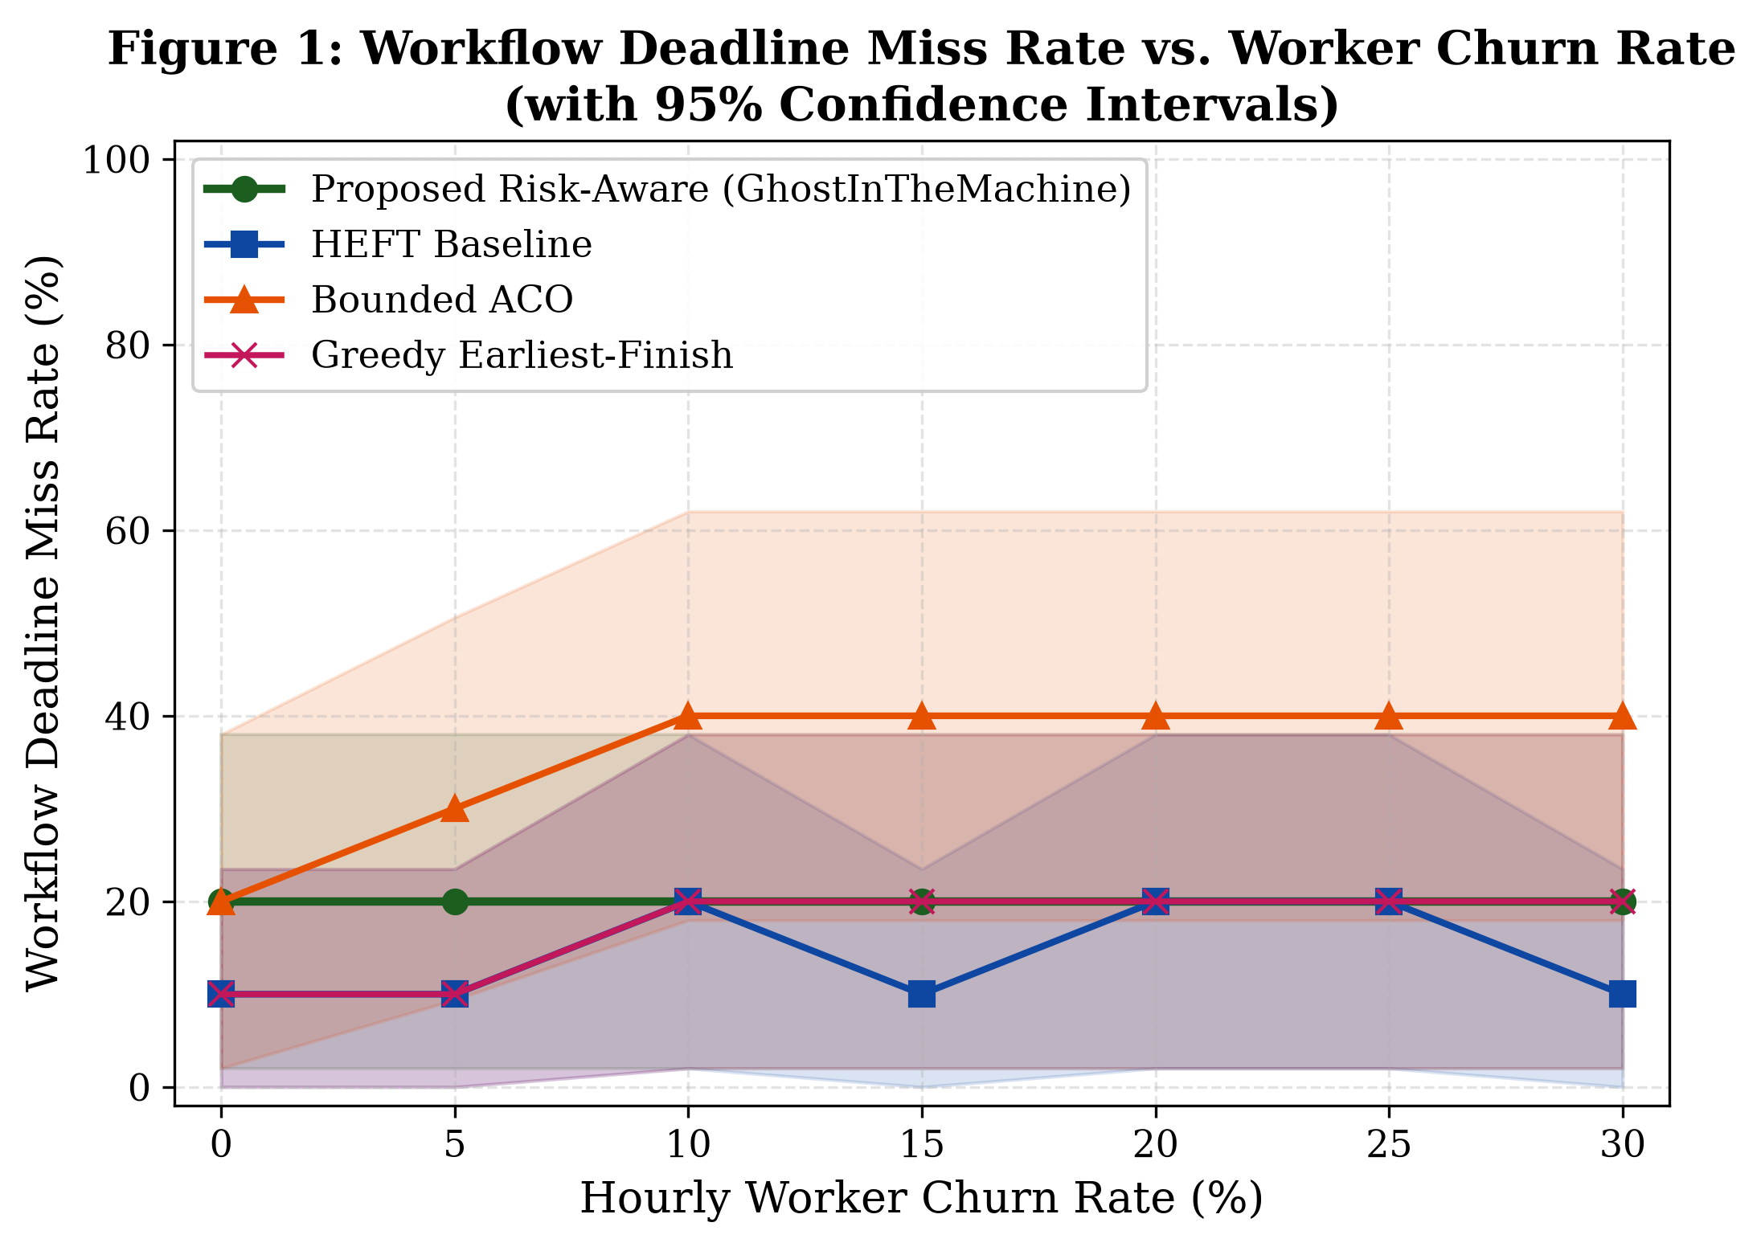
Figure 2: Workflow SLA Deadline Miss Rate vs. Churn Rate (95% CI).
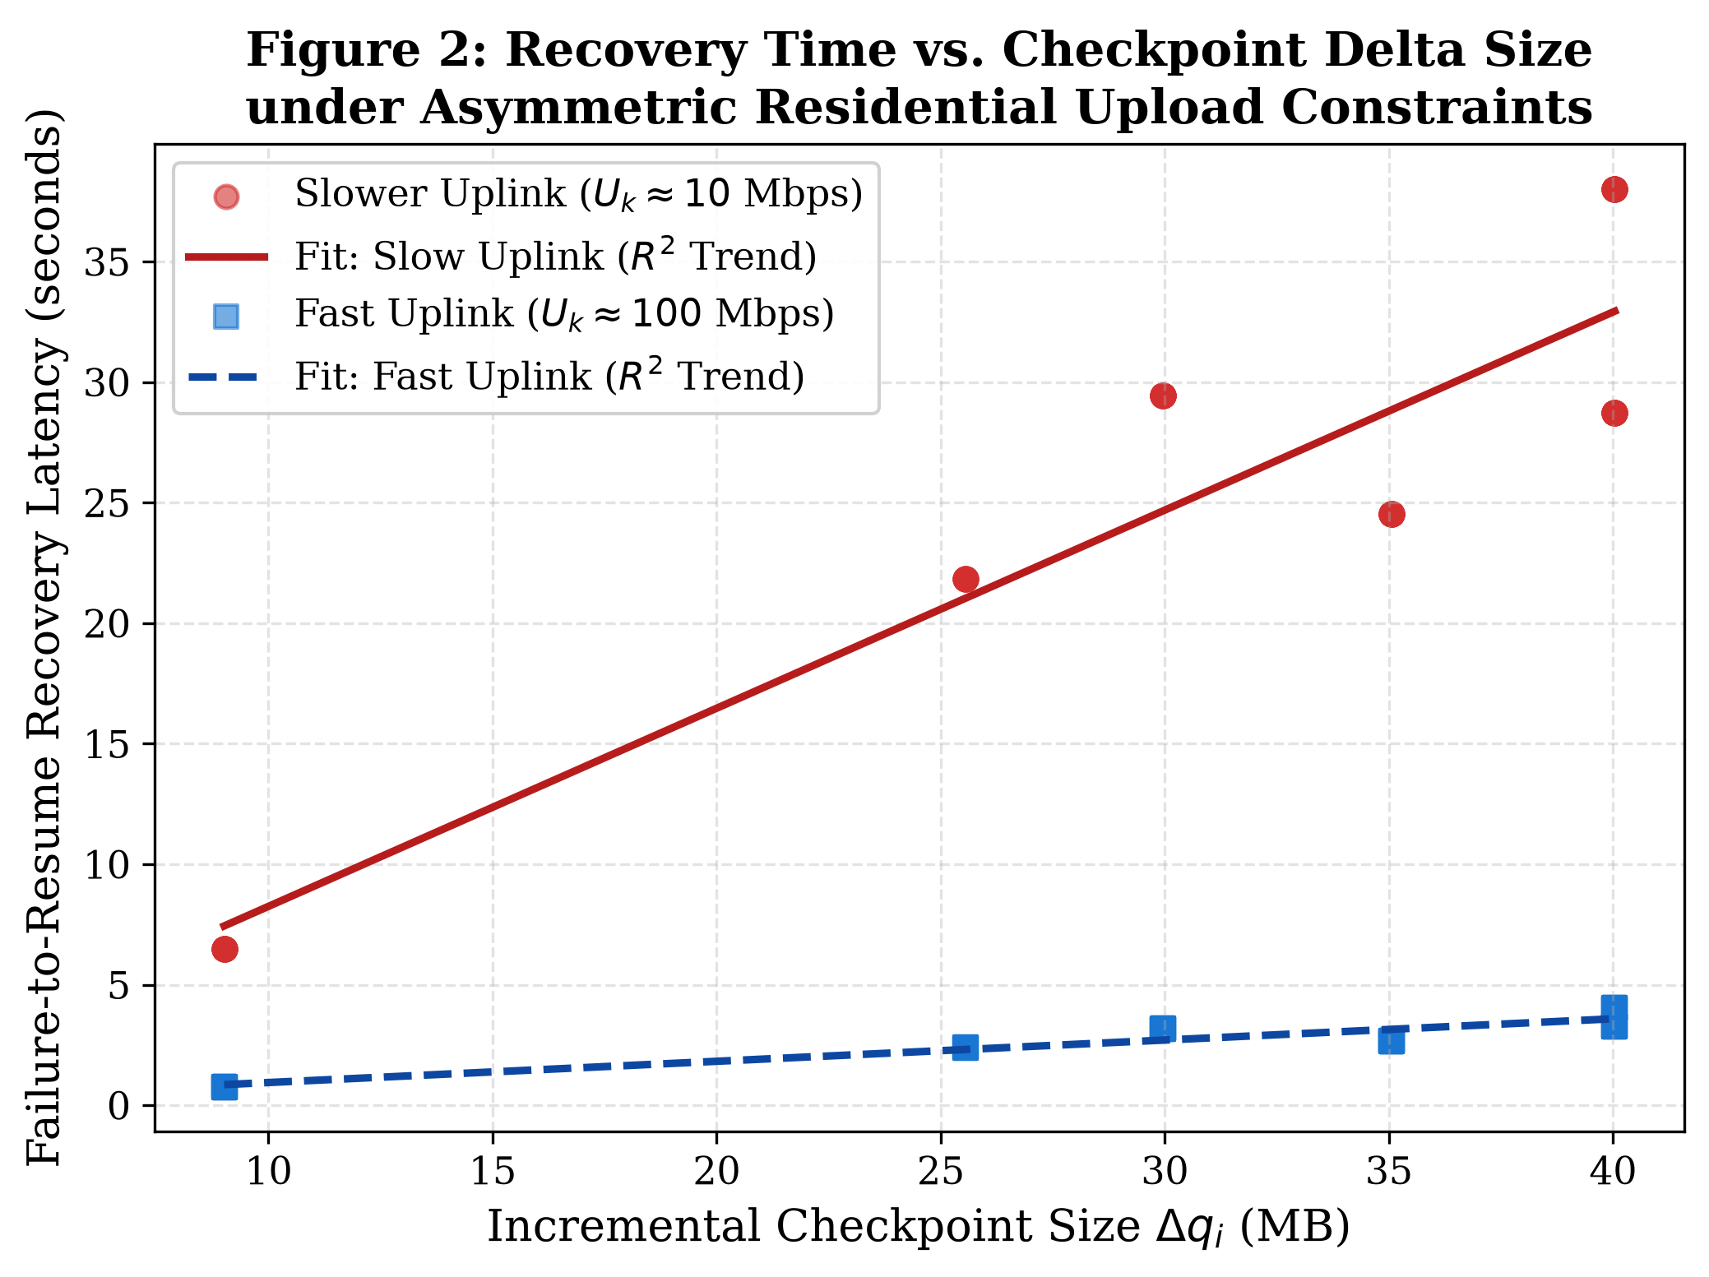
Figure 3: State Recovery Latency vs. Checkpoint Delta Size under Asymmetric Residential Uplinks.
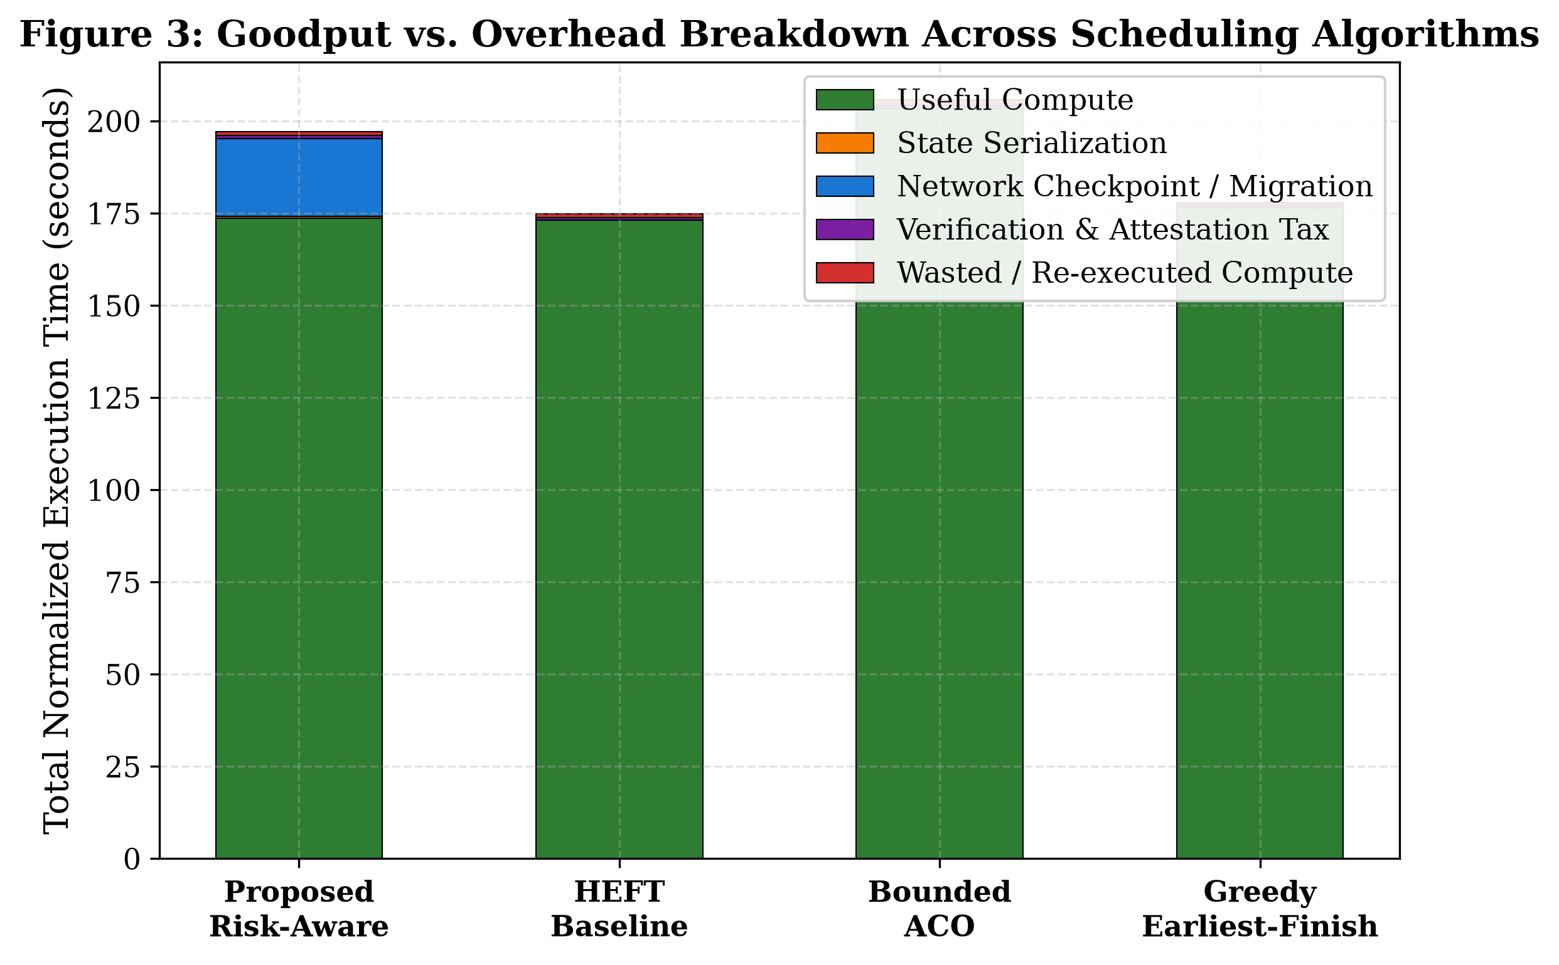
Figure 4: Goodput vs. Overhead Breakdown across algorithms compiled from 280 automated batch runs.

